Simulation Task 1 Report

*Group 45:*

Ahmad Magdy Muhammad Zaki (1)

Ahmad Abd El-Latif Mhana (1)

Ahmad Alaa Abd El-Wahab (1)

* The Problem Formulation and setting the objective:

**Problem Formulation:** We want to improve a system with some servers, and customers arrive in some distribution, we need to know the lack in the system or the bottleneck to fix it, improving System’s performance.

Our Simulation Program can understand any system similar to this one, like (Bank or Carrefour),

I have in my problem some given data:

1. Customer inter arrival time distribution

-This which indicates the probability of the arrival customers

2. Service time distribution for each server

-This which will give me the service time for each customer who uses this server

3. The way of selection between servers

- (Highest priority – Lowest utilization – Random)

**Objective:** Answering questions like, Servers idle occurrences, busy time, customers queue time, customers queue size, average customer delay, average server idle time, more like that.

By running the system hundreds of times, we can get a very accurate data for performance measure about this system, knowing where we should focus our improving to get the best advance.

Model Conceptualization

-Taking the User Input: #Servers, ServerSel, MaxCustomer, MaxClock,

CustomerDist, each ServerDist., each server Priority.

-Initialize: Assign the First Customer Arrival to the Server

-Foreach(Event in EventList)

If(Event is Arrival)

Assign Customer To Server

Else(Event is Departure)

Add Next Customer Arrival Event

* Experimental Design
* The Length of Simulation Runs, Trials: 1
* The Impact of different server selection policies

Lowest Priority:

Probability of Wait: 0.53

Average Customer Delay: 1.42

Server [1] Idle Probability: 0.0930232558139535

Server [2] Idle Probability: 0.176744186046512

Random Priority:

Probability of Wait: 0.45

Average Customer Delay: 1.07

Server [1] Idle Probability: 0.115207373271889

Server [2] Idle Probability: 0.110599078341014

Highest Priority:

Probability of Wait: 0.27

Average Customer Delay: 0.38

Server [1] Idle Probability: 0.243243243243243

Server [2] Idle Probability: 0.148648648648649

* The impact of different stopping conditions

With 100 Customers, 2 Servers, Highest Priority

Probability of Wait: 0.27

Average Customer Delay: 0.38

Server [1] Idle Probability: 0.243243243243243

Server [2] Idle Probability: 0.148648648648649

With 50 Customers, 2 Servers, Highest Priority

Probability of Wait: 0.48

Average Customer Delay: 0.7

Server [1] Idle Probability: 0.173913043478261

Server [2] Idle Probability: 0.104347826086957

* Results analysis and Conclusion

So we’ll choose the Highest Priority because it has the lowest Probability of Wait, and Lowest average Customer Delay

Inputs:



Graphs

Customer Delay Frequency :: (X,Y): (0,70)(1,10),(2,10),(3,7),(4,4)

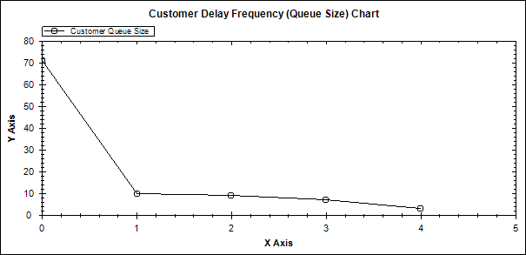

Customer Queue:: The servers busy was nearly 75% of the simulation

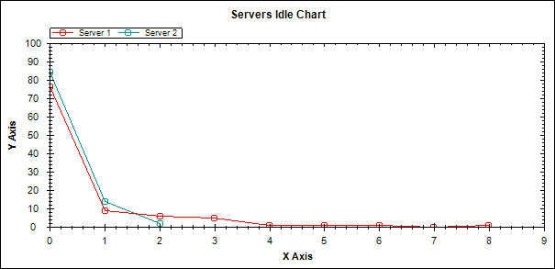

Servers Busy Time

The Times for each server it was busy

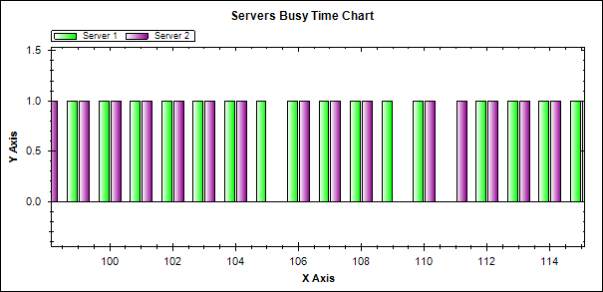

Program Screenshots

Startup Form (Taking Input from the User)

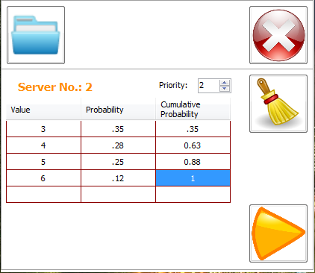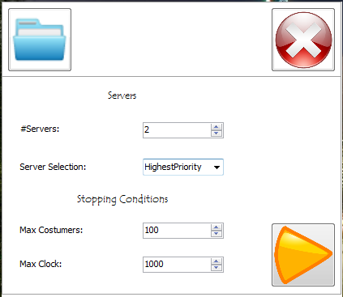

Main Form

Displaying Simulation table, with the Clock, Event

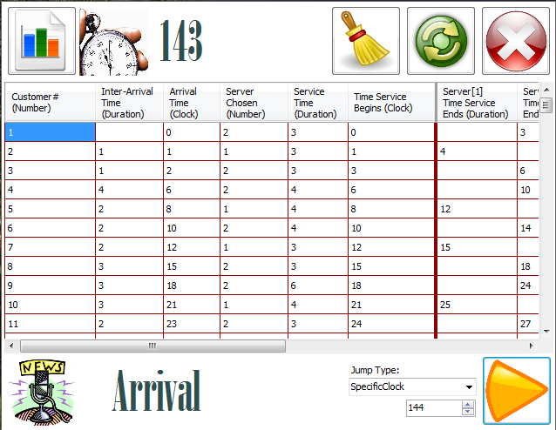

Performance Measure

Probability of Wait: “0.2786885”

Average Customer Delay: “0.37”

Server[1] Idle Probability: “0.23”

Server[2] Idle Probability: “0.05”

Graph: Server 1 was less Idle than Server 2

